**Experiment No. 2**

**Aim: Illustrate GIT PUSH and GIT PULL for version controlling of Java/Web application.**

**Lab Outcome No. : 9.ITL8003.2**

**Lab Outcome : Illustrate different version control strategies using Git**

**Date of Performance: 5/2/21 Date of Submission: 12/2/21**

|  |  |  |  |  |  |
| --- | --- | --- | --- | --- | --- |
| **Program formation/ Execution / Ethical practices (07 )** | **Documentation (02)** | **Timely Submission (03)** | **Viva Answer (03)** | **Experiment Marks (15)** | **Teacher Signature with date** |
|  |  |  |  |  |  |

**Experiment No 2**

**Aim :** Illustrate GIT PUSH and GIT PULL for version controlling Java/Web application.

**Lab Outcome No. :** 9.ITL8003.2

**Lab Outcome :** Illustrate different Version Control strategies using Git.

# Theory :

## Introduction to GIT

**Git** is an **open-source distributed version control system**. It is designed to handle minor to major projects with high speed and efficiency. It is developed to coordinate the work among the developers. The version control allows us to track and work together with our team members at the same workspace.

Git is a foundation of many services like **GitHub** and **GitLab**, but we can use Git without using any other Git services. Git can be used **privately** and **publicly**.

Performing Version control in GITHUB with Pull and Push commands

First open Github.com and create a new account. After verifying account through E-mail, create a Repository on github.com.

Open github.com create an account. After login Select New repository from the menu.

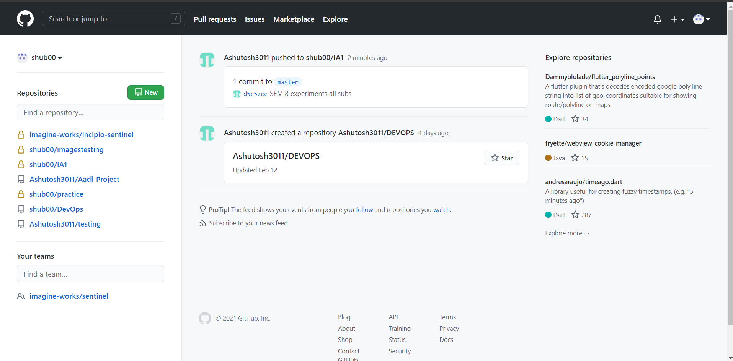

Now Specify a Name to repository and select public option followed by create repository

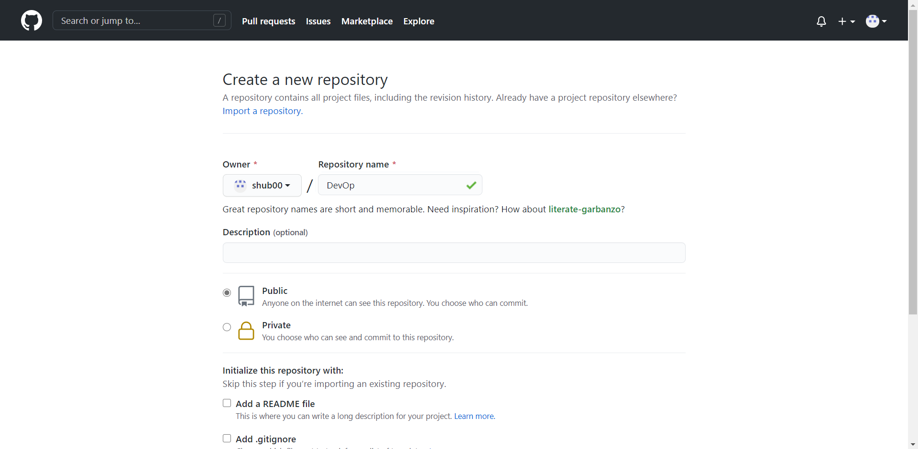

Now, if you want to download a repository in a local machine, then git clone command is used followed by a path to the repository. In GitHub the path of repository can be known through clone or download button and it can be downloaded using git clone command as shown below.

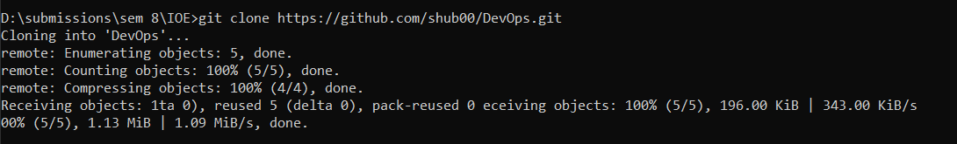

## Pull and Push Processes

The pull command used to fetch the repository from github to local while push is used to commit files from local repository to Github. Push pushes changes to Web Repository Pull pulls changes to Local repository

The following commands are used for pull and push repositories

## Push command

git init

git remote add origin https://github.com/shub00/DevOps.git

git add .

git commit -m "First Commit"

git push -u origin master

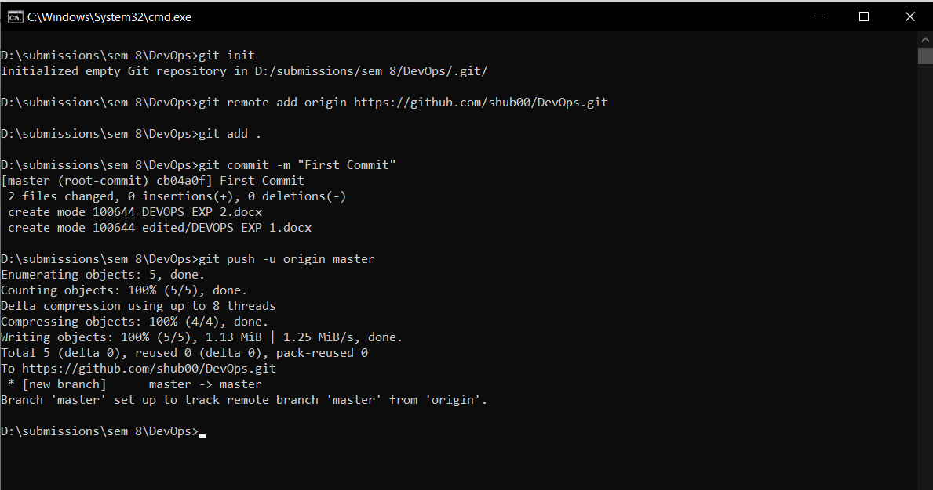

If you add remote again then will show you fatal error.

git remote add origin <https://github.com/shub00/DevOps.git>

fatal: remote origin already exists.



## Pull Changes

Pull command is used to download the remote updated repository into local one. The command for download is

git pull

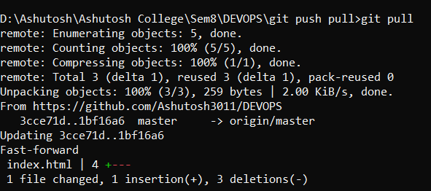

Now you can see the changes in local repository using git log.

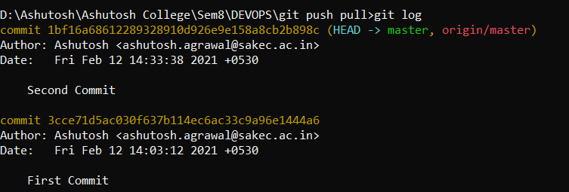

# Conclusion :

We have successfully understood the purpose of using a version control for collaboration. Application and usage of GIT Push and Pull commands was successfully executed.